

WHITEMARZ FARM CSA 2020 SEASON

389 Page St. Lunenburg, MA. 01462

(978) 227-2049

[www.whitemarzfarm.com](http://www.whitemarzfarm.com)

**Community Supported Agriculture (CSA)**

CSA is a direct connection between YOU and our farm.

For 19 weeks members will receive directly to their home a variety of fresh, in-season, locally grown vegetables. These vegetables are pesticide and herbicide free.

The shares are designed for one household, and typically feeds 2-4 people. The cost is $550 for the 19-week season.

You can expect 10 to 12 of these vegetables weekly:

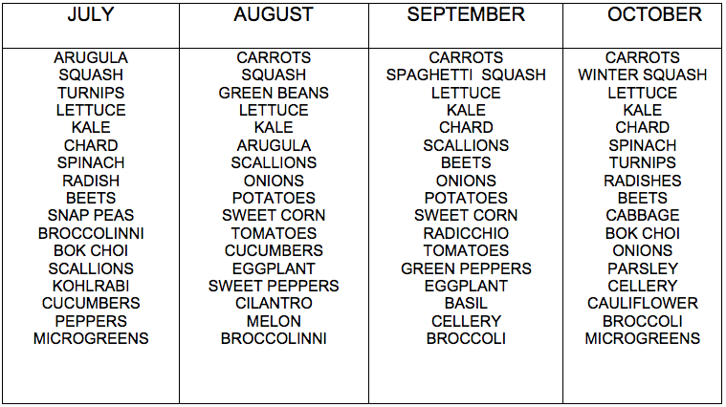

**WHITEMARZ FARM CSA ORDER FORM 2020**

**Name**:____________________________________________________________________

**Phone**:_____________________ **E-mail**:________________________________________

**Please choose prefered delivery day**: Sunday evening. ☐ Monday evening. ☐

Pick up at Lunenburg Farmers Market every Sunday. ☐ Pick up at Shirley Farmers Market every Thursday. ☐

**CSA Share delivery address (Lunenburg)**:________________________________________

**PAYMENT OPTIONS**

**-**CASH ☐ -CHECK ☐

THANK YOU FOR SUPPORTING LOCAL AGRICULTURE!