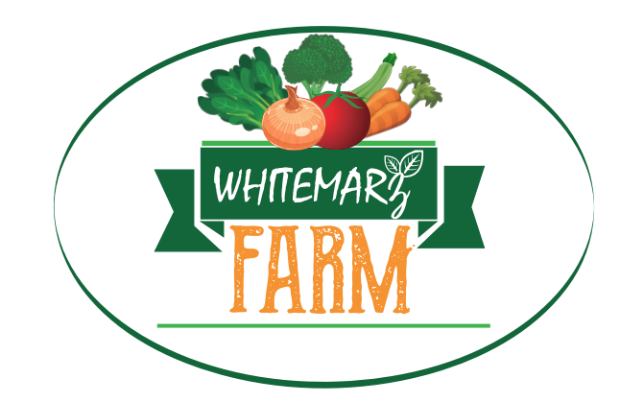
WHITEMARZ FARM CSA SEASON 2021
389 Page St. Lunenburg, MA 01462 * (978) 227-2049
www.whitemarzfarm.com

COMMUNITY SUPPORTED AGRICULTURE (CSA)
WEEKLY VEGETABLE SHARE
Whitemarz Farm offers non sprayed Weekly Vegetable CSA shares delivered to your door. The CSA runs for 19 weeks. Members will receive their share on the same day every week. You can also pick up your share at the Lunenburg Farmers Market on Sundays between 10:00am-1:00pm.

For the 2020 season we will be offering two different CSA options to offer the most flexibility for you!

1.TRADITIONAL. Pre-boxed best value CSA shares contain between 10 to 12 different vegetables, reflecting what’s in season on the farm. The cost is $550 for the 19-week season.
2.CSA your way: This option will contain 10 products which you choose 4 days before delivery. We will send a message with our produce availability for that week and you can choose 10 of those products for that week. The cost is $600.00 for the 19-week season.

Our CSA´s are known for high quality, very clean, non sprayed vegetables! We grow more than 40 different crops. The shares are designed for one household, and typically feed 2 – 4 people.
You can expect the following vegetables during these months:
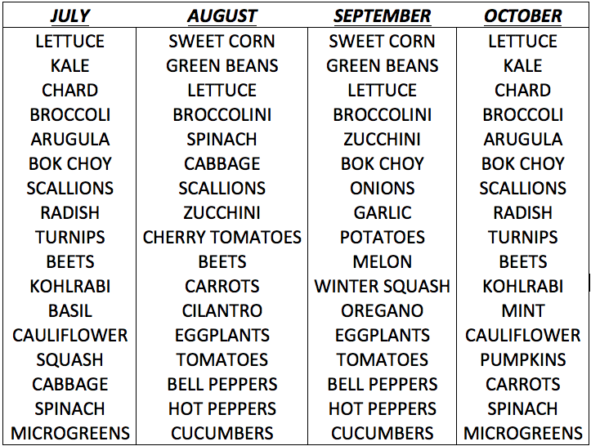

WHITEMARZ FARM CSA ORDER FORM 2021
Name:__________________________________________________Phone:____________________
E-mail:____________________________ Delivery adress:_________________________________
Please choose your CSA option:
1. Best value traditional CSA. $550.00 ☐
2. CSA your way. $600.00 ☐

PAYMENT OPTIONS
-CASH☐ -CHECK (make checks payable to Whitemarz Farm)☐
-VENMO☐ -OTHER☐___________

THANK YOU FOR SUPPORTING LOCAL AGRICULTURE!

