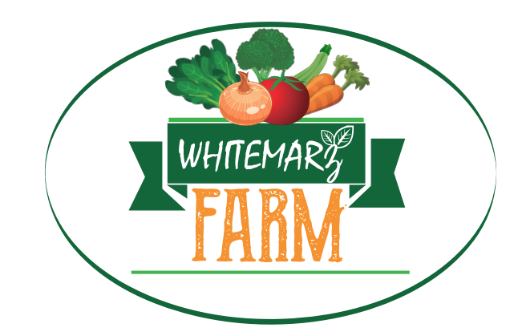
WHITEMARZ FARM CSA SEASON 2020
389 Page St. Lunenburg, MA 01462 * (978) 227-8077
www.whitemarzfarm.com

COMMUNITY SUPPORTED AGRICULTURE (CSA)
WEEKLY VEGETABLE SHARE
Whitemarz Farm offers non sprayed Weekly Vegetable CSA shares delivered to your door. The CSA runs for 19 weeks. Members will receive their share on the same day every week. You can also pick up your share at the Lunenburg Farmers Market on Sundays between 10:00am-1:00pm.

For the 2020 season we will be offering two different CSA options to offer the most flexibility for you!

1.TRADITIONAL. Pre-boxed best value CSA shares contain between 10 to 12 different vegetables, reflecting what’s in season on the farm. The cost is $550 for the 19-week season.
2.CSA your way: This option will contain 10 products which you choose 4 days before delivery. We will send a message with our produce availability for that week and you can choose 10 of those products for that week. The cost is $600.00 for the 19-week season.

Our CSA´s are known for high quality, very clean, non sprayed vegetables! We grow more than 40 different crops. The shares are designed for one household, and typically feed 2 – 4 people.
You can expect the following vegetables during these months:

JULY | AUGUST | SEPTEMBER | OCTOBER
ARUGULA  SQUASH  TURNIPS  LETTUCE  KALE  CHARD  SPINACH  RADISH  BEETS  SNAP PEAS  BROCCOLINNI  BOK CHOI  SCALLIONS  TOMATOES  CUCUMBERS  GREEN PEPPERS  MICROGREENS | CARROTS  SQUASH  GREEN BEANS  LETTUCE  KALE  ARUGULA  GARLIC  ONIONS  POTATOES  SWEET CORN  TOMATOES  CUCUMBERS  EGGPLANT  SWEET PEPPERS  CILANTRO  MELON  BROCCOLINNI | CARROTS  SPAGHETTI SQUASH  LETTUCE  KALE  CHARD  SCALLIONS  BEETS  ONIONS  POTATOES  SWEET CORN  RADICCHIO  TOMATOES  GREEN PEPPERS  EGGPLANT  BASIL  CELERY  BROCCOLI | CARROTS  WINTER SQUASH  LETTUCE  KALE  CHARD  SPINACH  TURNIPS  RADISH  BEETS  CABBAGE  BOK CHOI  ONIONS  PARSLEY  CELERY  CAULIFLOWER  BROCCOLI  MICROGREENS

WHITEMARZ FARM CSA ORDER FORM 2020
Name:__________________________________________________Phone:____________________
E-mail:____________________________ Delivery adress:_________________________________
Please choose your CSA option:
1. Best value traditional CSA. $550.00 ☐ delivery day Monday evening.
2. CSA your way. $600.00 ☐ delivery day Sunday evening.

PAYMENT OPTIONS
-CASH☐ -CHECK (make checks payable to Whitemarz Farm)☐
-VENMO☐ -OTHER☐___________

THANK YOU FOR SUPPORTING LOCAL AGRICULTURE!

